

This year, Dwellingup PS has

**This year, Dwellingup PS has combined with Jarrahdale PS to make a combined team for the games.**

|  |  |  |
| --- | --- | --- |
|  | | |
|  | Junior Girls Throw |  |
|  | Junior Boys Throw |  |
|  | Senior Boys  Triple Jump **(PIT 1)** |  |
|  | Intermediate Girls  Long Jump |  |
|  | Intermediate Boys Throw |  |
|  | Senior Boys  Long Jump **(PIT 2)** |  |
|  | Senior Girls Triple Jump **(PIT 1)** |  |
|  | Senior Boys Throw |  |
|  | Senior Girls Throw |  |
|  | Junior Girls Long Jump **(PIT 1)** |  |
|  | Junior Boys  Long Jump **(PIT 2)** |  |
|  | Intermediate Girls Throw |  |
|  | Intermediate Boys Long Jump **(PIT 1)** |  |
|  | Senior Girls  Long Jump **(PIT 2)** |  |
|  | | |
|  | Senior Boys 400m |  |
|  | Senior Girls 400m |  |
|  | Intermediate Boys 200m |  |
|  | Intermediate Girls 200m |  |
|  | Junior Boys 100m |  |
|  | Junior Girls 100m |  |
|  | Senior Boys 100m |  |
|  | Senior Girls 100m |  |
|  | Intermediate Boys 75m |  |
|  | Intermediate Girls 75m |  |
|  | Junior Boys 50m |  |
|  | Junior Girls 50m |  |
|  | Junior Girls Tunnel Ball (8) |  |
|  | Junior Boys Tunnel Ball (8) |  |
|  | Intermediate Girls Tunnel Ball (8) |  |
|  | Intermediate Boys Tunnel Ball (8) |  |

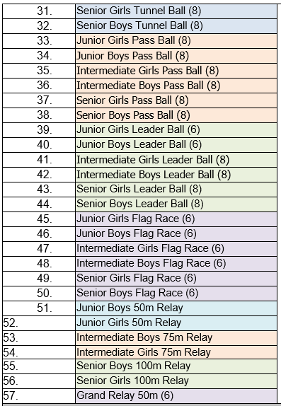

**Presentations approx. 2:20pm**